REST API Client
User Manual
Version 1.0 | June 2026

1. Overview
REST API Client is a single-file browser application for sending HTTP requests and inspecting responses — similar to Postman, but requiring no installation. Open rest-client.html directly in any modern browser.

Refer to https://app.swaggerhub.com/organizations/universalrobots-api for latest documentation on UR Robot API.

Key capabilities:
- Send GET, POST, PUT, PATCH, and DELETE requests
- Add custom headers with a key-value editor
- Write a JSON request body
- View formatted response body and headers
- Quick-access built-in JSONPlaceholder examples
- Universal Robots (UR) API quick-select panel
- Request history (last 20 requests auto-saved)
- Dark and light themes
- Adjustable font size
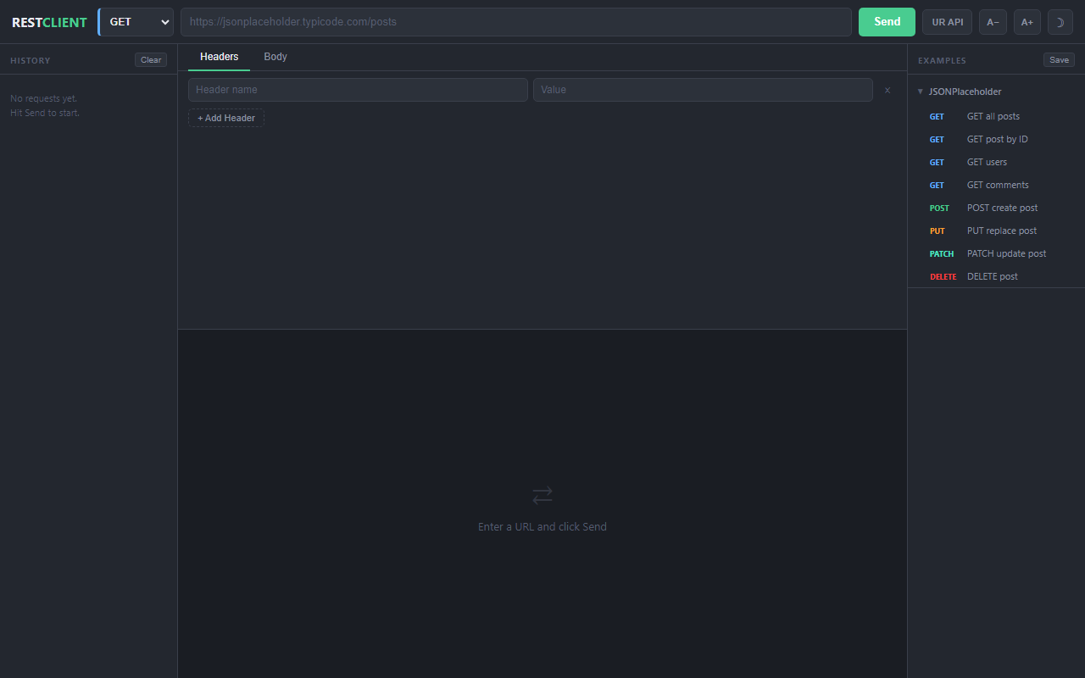

2. Interface Layout
The application is divided into four main areas:
- Top bar — method selector, URL input, Send button, and utility buttons
- Left sidebar — request history
- Main workspace — request headers/body editor and response panel
- Right sidebar — built-in example collections
The UR API panel (see Section 5) sits between the top bar and the workspace, and is hidden by default.

3. Sending a Basic Request

3.1 GET Request
1. Select GET from the method dropdown on the left of the URL bar.
2. Type or paste a URL into the address field (e.g. https://jsonplaceholder.typicode.com/posts/1).
3. Click Send.
4. The response body appears in the lower workspace panel. The status code, time, and size are shown above the response.

3.2 POST / PUT / PATCH Request
1. Select the desired method (POST, PUT, or PATCH).
2. Enter the endpoint URL.
3. Click the Body tab in the request panel and type a JSON payload.
4. Add a Content-Type: application/json header in the Headers tab (the UR API panel does this automatically).
5. Click Send.
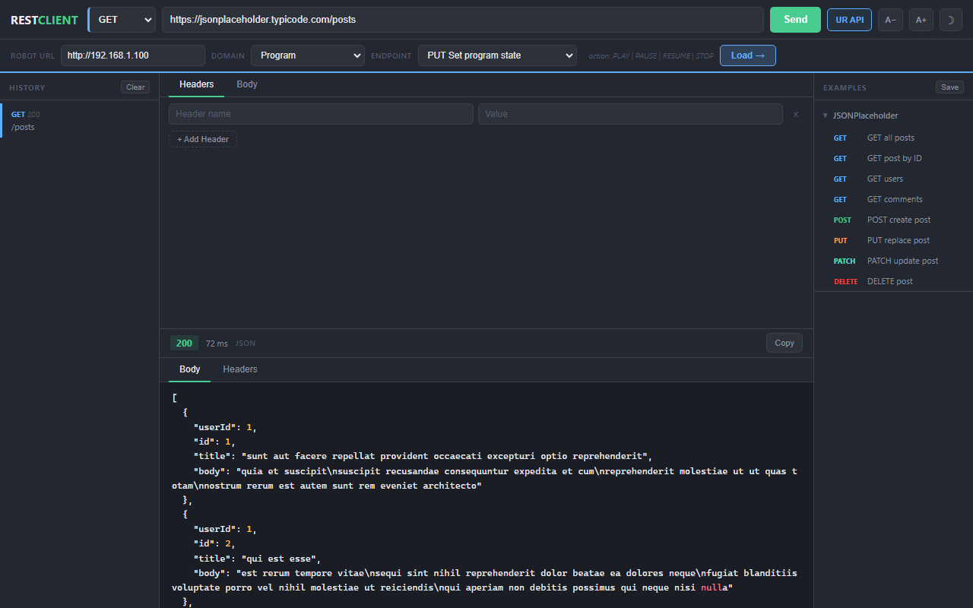

3.3 Response Panel
The response panel has two tabs:
- Body — formatted and syntax-highlighted JSON (or raw text)
- Headers — all response headers returned by the server
A Copy button at the top right copies the raw response body to the clipboard.
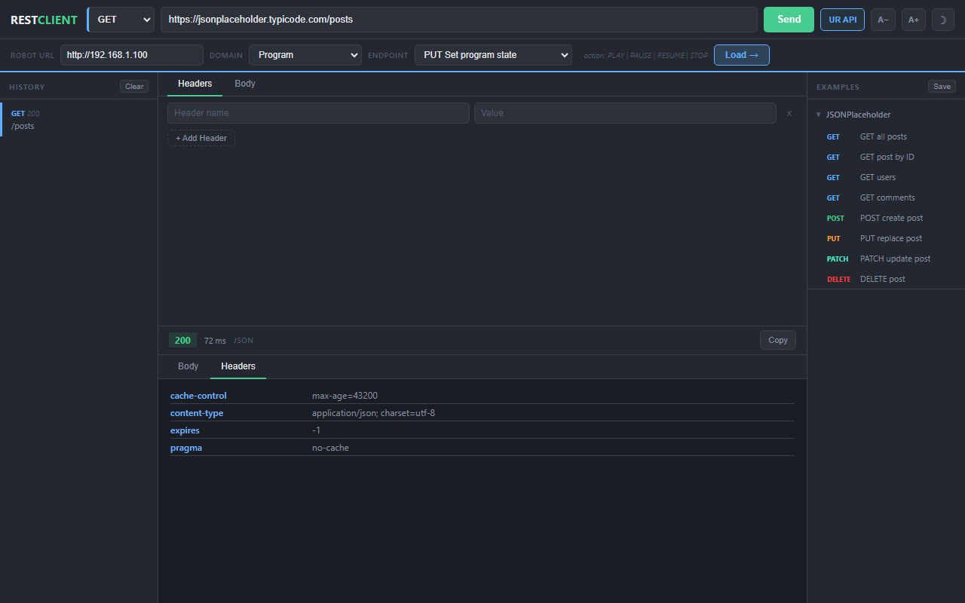

4. Headers Editor
Click the Headers tab in the request panel to add custom request headers.
- Click + Add Header to insert a new key-value row.
- Type the header name in the left field and its value in the right field.
- Click the red x button on the right to remove a row.
Common headers:
- Content-Type: application/json — required for JSON body requests
- Authorization: Bearer <token> — for authenticated endpoints
- Accept: application/json — request JSON responses

5. Universal Robots (UR) API Panel
The UR API panel provides quick access to the Universal Robots Robot API. Click the UR API button in the top bar to open or close it.
Refer to https://app.swaggerhub.com/organizations/universalrobots-api for latest documentation on Robot API.
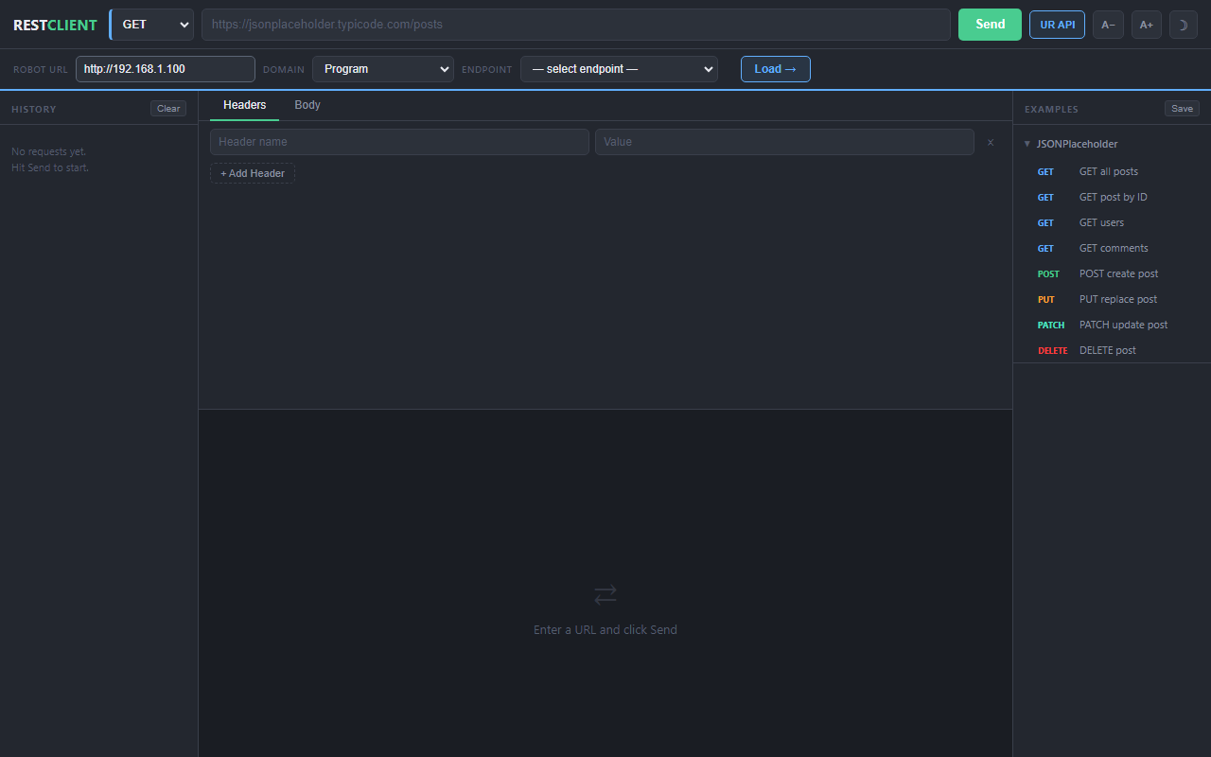

5.1 Connecting to a Robot
1. Enter your robot's base URL in the Robot URL field (e.g. http://192.168.1.100).
2. Select an API domain from the Domain dropdown: License, Program, Robotstate, or System.
3. Select an endpoint from the Endpoint dropdown.
4. Click Load to populate the main request form.
5. Click Send as usual.
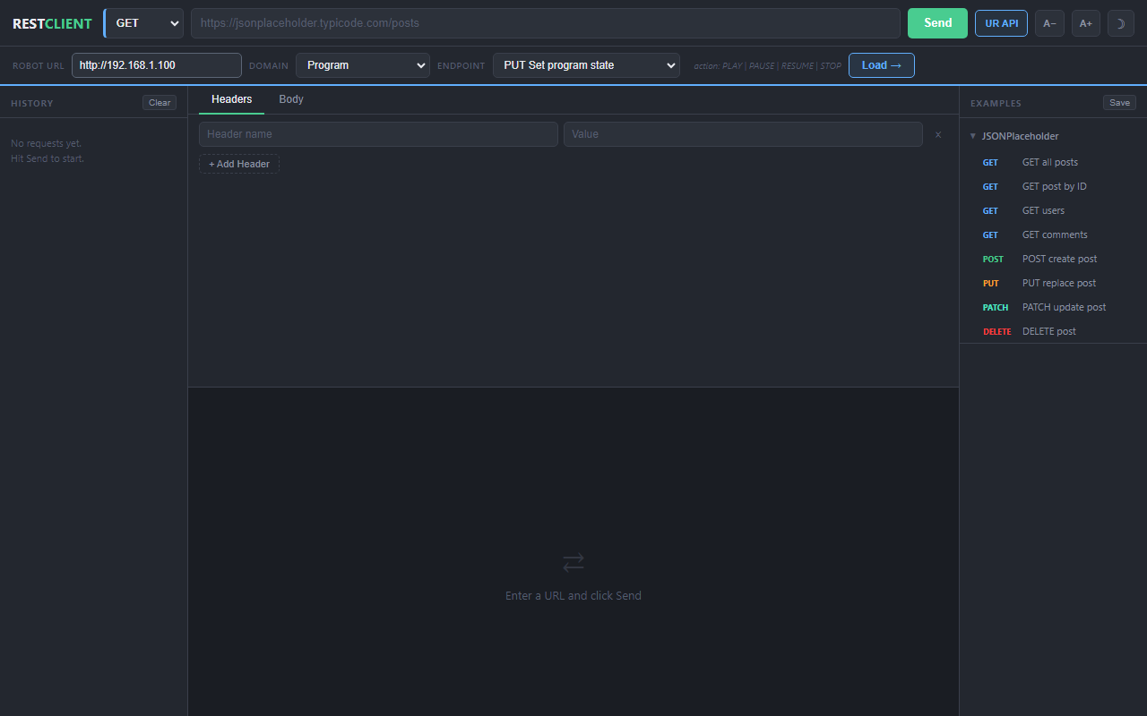

5.2 Endpoints with Path Parameters
Some endpoints require values embedded in the URL path (e.g. vendor_id and product_code for the License API). When such an endpoint is selected, input boxes appear in the panel for each parameter.
Fill in the parameter values before clicking Load. The values are substituted into the URL automatically.
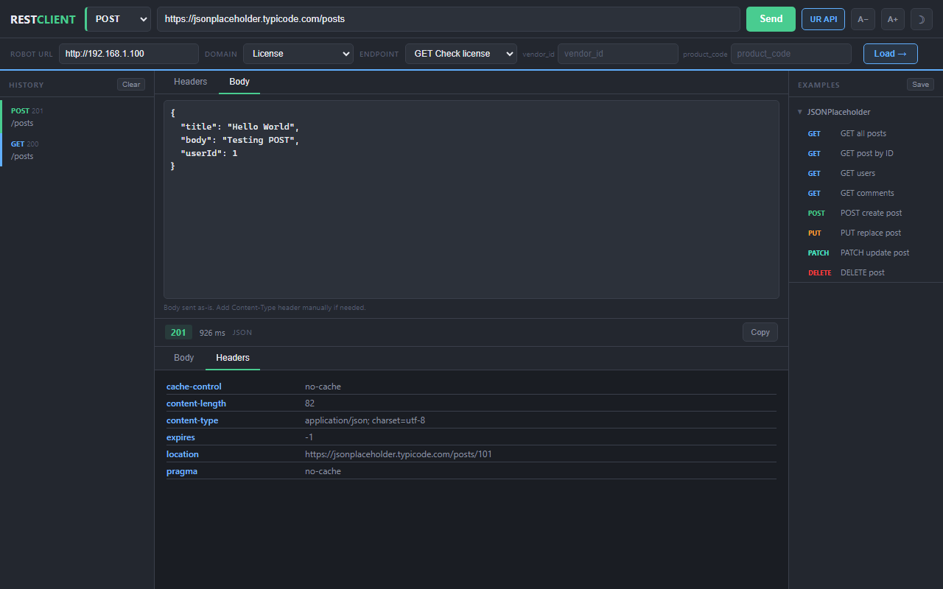

5.3 Automatic Content-Type Header
For PUT and POST endpoints that include a request body, the UR API panel automatically adds a Content-Type: application/json header when loading the endpoint. You do not need to add it manually.
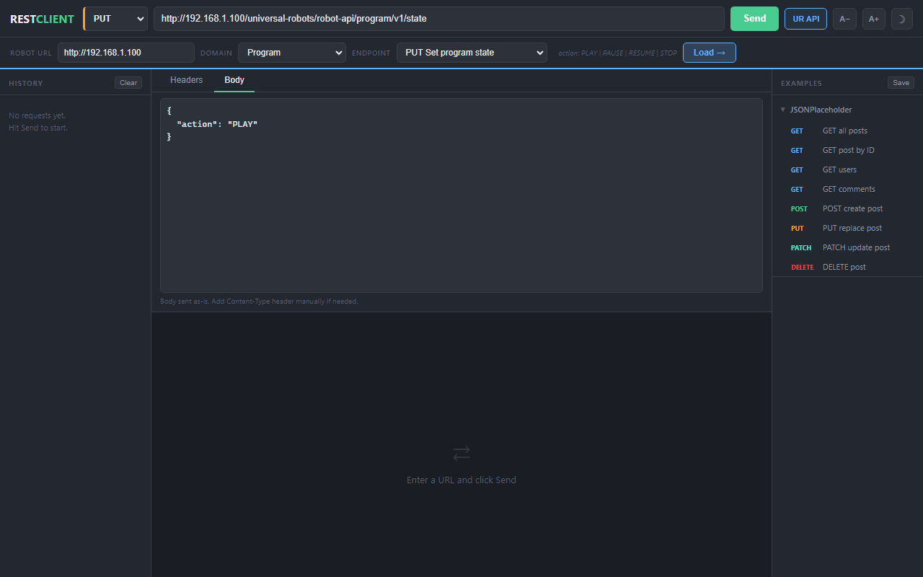

5.4 CORS and Network Errors
Note: If the app is opened from a file:// URL (double-clicked), the browser may block requests to http:// robot addresses. For best results, serve the file over a local HTTP server (e.g. python -m http.server 3456) and open http://localhost:3456/rest-client.html.
Note: Robot firmware must have CORS headers enabled. If you see "Failed to fetch", confirm the robot IP is reachable from your machine by opening the URL directly in a browser tab first.

6. Request History
Every request is automatically saved in the left sidebar. Up to 20 recent requests are stored.
- Click any history entry to restore the method, URL, headers, and body.
- History persists across page reloads (stored in browser localStorage).
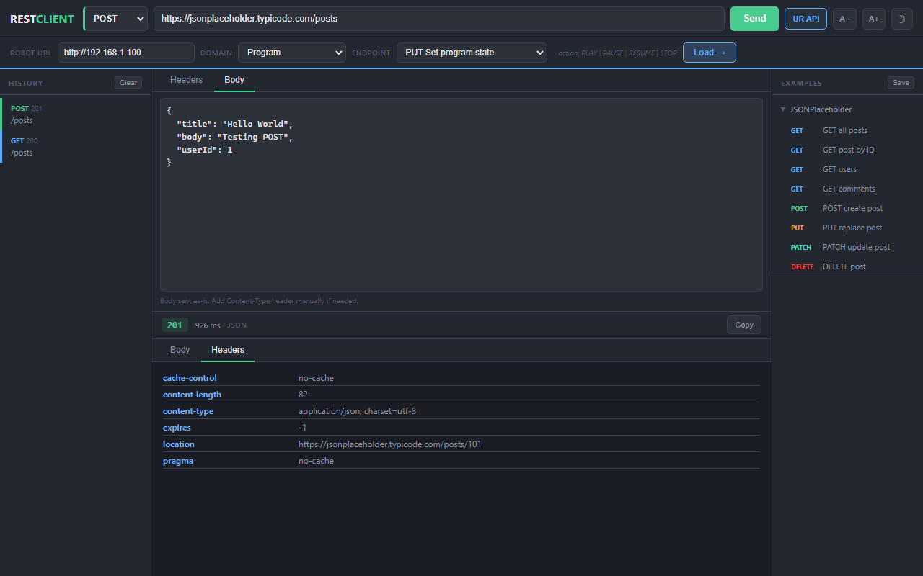

7. Built-in Example Collections
The right sidebar contains pre-built request examples. Click any item to load it into the request form immediately.
The JSONPlaceholder collection covers all common HTTP methods against a public test API:
- GET all posts
- GET post by ID
- POST create post
- PUT replace post
- PATCH update post
- DELETE post
- GET users

8. Appearance Settings

8.1 Dark / Light Theme
Click the theme toggle button in the top bar to switch between dark (default) and light themes. The preference is saved and restored on reload.
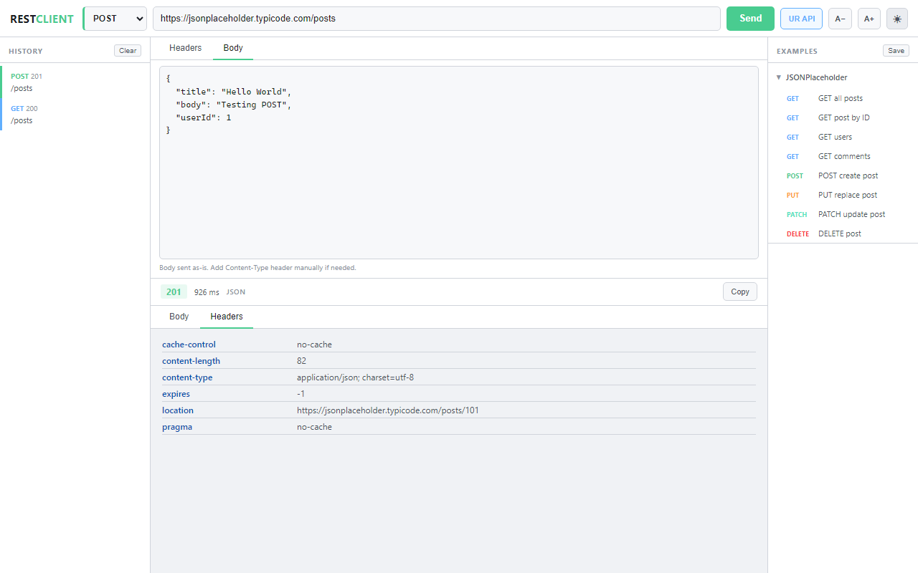

8.2 Font Size
Use the A- and A+ buttons in the top bar to decrease or increase the interface font size. The zoom level ranges from 70% to 180% in 10% steps and is saved across sessions.

9. Troubleshooting
Failed to fetch / Network Error
- Verify the URL is reachable (open it directly in a browser tab).
- Robot endpoints use HTTP — the app detects private IP ranges and uses http:// automatically.
- If running from file://, switch to http://localhost:3456/rest-client.html.
- Check that the robot is powered on and the network interface is connected.
422 Unprocessable Entity
- This means the server received the request but rejected the body format.
- Ensure Content-Type: application/json is set (the UR panel adds this automatically).
- Check that the JSON body is valid and matches the expected schema shown in the Body hint.
CORS Error
- CORS is enforced by the browser when a web page makes cross-origin requests.
- For robot endpoints, the robot firmware must send CORS response headers.
- For public APIs, ensure you are using the correct URL (https:// for non-local addresses).

